Independent Learning in A-level Fashion and Textiles

Consolidation – after every lesson
NEA Coursework
- Consider work which can be undertaken in study time. Email/see teacher if clarification is needed on any coursework areas you are unsure of so that study time is not wasted
Theory
- Read back on work completed in lesson, highlight any key terms
- Ensure work is placed in your folder in order. Remember your folder is revision for both examinations so it important to file work in an organised manner
- Fill in any gaps from tasks you did not have time to complete in lesson
- A key terms glossary can be created to support revision of each topic covered
- Flashcards also work well to list key terms and definitions. These can be done by hand or using online versions
Formal home learning
NEA Coursework
- Complete individual NEA tasks to back up the work undertaken in lesson. Researching, designing, writing up analysis/evaluations etc…
- When working on practical areas of coursework liaise with your teacher, you can arrange study times/after school sessions where you can work in the classroom to use practical equipment and complete tasks
Theory
- Complete homework tasks to back up the work undertaken in lesson. This may be research tasks in preparation for future lessons or practice exam questions
- Extend research in topic areas covered to further develop your knowledge
- Email/see your teacher if you need further support rather than waiting until the next lesson
- Revision tasks will be set by your teacher at key points in the school year (retrieval tests and progress exams)
Wider reading and extension
- A-level Design and Technology 7562 | Assessment Resources | AQA The AQA website has past papers and mark schemes. These are useful tools to test your knowledge for both exam papers
- There are a range of books in the learning resource centre in school. These may be useful for NEA coursework tasks and revision
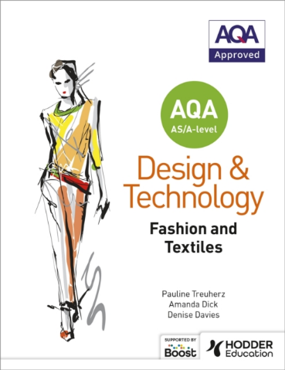
- The main book for A level revision is –

